IMPORT DATA USING TRASFORM MAPS
(SPREAD SHEET)
Project Design phase
System Overview
The project is designed to import data from an Excel spreadsheet into the ServiceNow platform using Import Sets and Transform Maps. The spreadsheet acts as the source of data, while ServiceNow processes and transforms the data before storing it in the selected target table.
The overall process consists of preparing the spreadsheet, uploading the data through an Import Set, creating a Transform Map, mapping the source fields to the target fields, executing the transformation, and verifying the imported records.
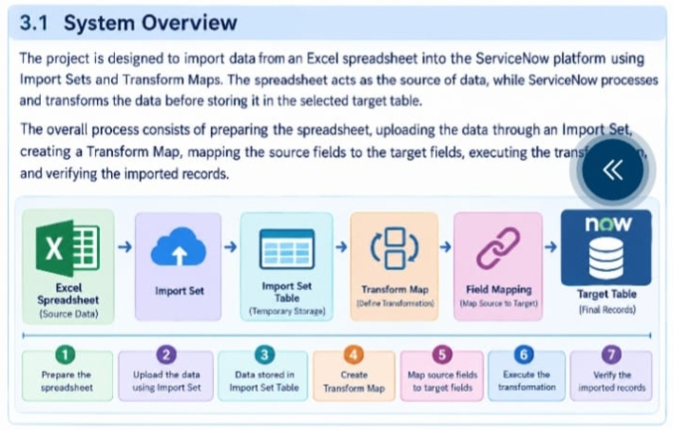
System Architecture
The system architecture consists of the following components:
1. Excel Spreadsheet – Contains the source data.
2. Import Set – Loads the spreadsheet data into ServiceNow.
3. Import Set Table – Temporarily stores the imported source data.
4. Transform Map – Defines how the source data should be transferred to the target table.
5. Field Mapping – Connects the source fields with the corresponding target fields.
6. Target Table – Stores the final transformed records.
The basic architecture is:
Excel Spreadsheet → Import Set → Import Set Table → Transform Map → Target Table.
Data Flow Diagram
The data flow of the project is designed as follows:
Step 1: The user prepares employee data in an Excel spreadsheet.
Step 2: The spreadsheet is uploaded to ServiceNow using the Import Set process.
Step 3: The imported data is stored temporarily in an Import Set Table
Step 4: A Transform Map is created to define the transformation process.
Step 5: Source fields are mapped to the corresponding target fields.
Step 6: The Transform Map is executed.
Step 7: The transformed data is inserted or updated in the ServiceNow target table.
Step 8: The final records are verified in the target table.
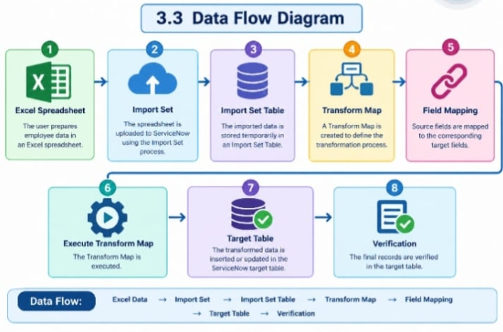
Data Flow
Excel Data → Import Set → Import Set Table → Transform Map → Field Mapping → Target Table → Verification
Spreadsheet/Data Structure
The Excel spreadsheet is used as the source data for the project. The spreadsheet should contain properly defined column headers and corresponding records.
A sample spreadsheet structure is:
Field Name| Sample Value
Employee Name| User1, User2, User3, User4, User5, User5
Employee ID|SB0001, SB0002, SB0003, SB0004, SB0005, SB0006

Email| user1@gmail.com, user2@gmail.com, user3@gmail.com, user4@gmail.com,
user5@gmail.com, user6@gmail.com,
Department.
ServiceNow, ServiceNow, ServiceNow, ServiceNow, Salesforce, Salesforce
The spreadsheet should be properly formatted and should not contain unnecessary blank rows, columns, or incorrect data.
Import Set Design
The Import Set is designed to load the spreadsheet data into ServiceNow before the transformation process.
The Import Set process includes:
Uploading the Excel spreadsheet.
Selecting the appropriate import option.
Loading the spreadsheet data into ServiceNow.
Creating or using an Import Set Table.
Checking the imported source records.
Preparing the data for transformation.
The Import Set Table temporarily holds the source data before it is transferred to the target table.
Transform Map Design
The Transform Map is designed to define how the imported source data should be transferred to the ServiceNow target table.
The Transform Map connects the Import Set Table with the target table. It specifies the source and target fields and controls how the data is transformed during the import process.
For this project, the Transform Map is used to transfer employee information from the imported spreadsheet into the appropriate fields of the target ServiceNow table.
Field Mapping Design
Field mapping defines the relationship between the fields in the spreadsheet and the fields in the ServiceNow target table.
The mapping can be designed as follows:
Source Field| Target Field
Employee Name| SB0001, SB0002, SB0003, SB0004, SB0004, SB005, SB0006.
Employee ID| User1, User2, User3, User4, User5, User6.
Email| user1@gmail.com, user2@gmail.com, user3@gmail.com, user4@gmail.com,
user5@gmail.com, user6@gamail.com.
Department| ServiceNow, ServiceNow,ServiceNow, ServiceNow, Salesforce, Salesforce.
Location| Tamil Nadu, Tamil Nadu, Tamil Nadu, Tamil Nadu, Tamil Nadu, Tamil Nadu.
For example, the value in the Employee Name field of the spreadsheet is transferred to the Name field in the target table. Similarly, the other source fields are mapped to their corresponding target fields.
Target Table Design
The target table is the final location where the transformed spreadsheet data is stored in ServiceNow.
The target table should contain the required fields to store the imported employee information.
A sample target table structure is
Target Field| Description
Name| Stores the employee name
Employee ID| Stores the unique employee identification number
Email| Stores the employee email address.
After the Transform Map is executed, the transformed records are stored in the target table. The final records are then verified to ensure that the data has been imported correctly. 

